FIFA World Cup Prediction Project Report (week 1, week 2)
Task 1: Data Collection and Preparation
- Dataset Description: using Kaggle website
- Datasets like
- fifa_ranking_2022-10-06
- Matches_1930_2022
- World_cup
- Fifa
all this datasets merged into one final dataset that is cleaned_fifa_dataset
The dataset contains historical FIFA World Cup match data. Each column represents important features affecting match outcomes:
Column | Description
Rank Difference | Difference in FIFA ranking between home and away teams.
Points Difference | Difference in points accumulated by home and away teams.
Home Team Avg Age | Average age of players in the home team.
Away Team Avg Age | Average age of players in the away team.
Home Team Experience | Total experience (matches played) of home team players.
Away Team Experience | Total experience of away team players.
Home Team Win Rate | Historical win rate of home team.
Away Team Win Rate | Historical win rate of away team.
Home_Win | Target variable indicating match outcome: Home Win (1), Draw (0), Away Win (-1).
- Data Cleaning Steps
- Removed duplicate entries.
- Handled missing values: imputed where possible, removed rows where necessary.
- Ensured all numeric columns have correct data types.
- Feature Engineering
- Created features to capture relative team strength: Rank Difference, Points Difference.
- Selected numeric features like team average age, experience, and win rates.
- Custom Web Scraper
- Custom Scraping Source:
  - Site Targeted: FIFA World Cup 2022 Teams
  - Reason: To extract the latest squad and team info (year, host, champions,attendance, top scores).
- Scraping Logic:
  - Use requests to fetch the webpage.
  - Parse HTML using BeautifulSoup.
  - Locate team sections and extract name, logo, and links.
  - Save results to CSV.
- Challenges: Dynamic content loading, missing links, ensuring CSV consistency.
- Cleaned Dataset
- A CSV file containing all columns explained above.
- Ready for model building.
Task 2: Model Building and Training
- Models Implemented
- Logistic Regression
- Random Forest
- Preprocessing Steps
- Numeric features scaled for Logistic Regression.
- Random Forest works on raw numeric features; no scaling needed.
- No encoding was required since all features are numeric.
- Hyperparameter Tuning
- Logistic Regression: Tested different C values for regularization. Solver set to lbfgs for multiclass handling.
- Random Forest: Tuned number of trees, maximum depth, and minimum samples for splits and leaf nodes.
- Model Evaluation
- Train-test split (80-20) and 5-fold cross-validation to ensure fair evaluation.
Metrics:
Logistic Regression K-Fold Accuracy:
- Fold Accuracies: 58.03%, 60.10%, 66.32%, 63.73%, 65.10%
- Average Accuracy: 62.66%
Random Forest:
- Best Parameters: {'max_depth': 5, 'min_samples_leaf': 2, 'min_samples_split': 2, 'n_estimators': 100}
- Accuracy on Test Set: 63.73%
- K-Fold Accuracy: 57.51%, 58.55%, 67.36%, 63.21%, 61.97%
- Average Accuracy: 61.72%
- Example Predictions
- 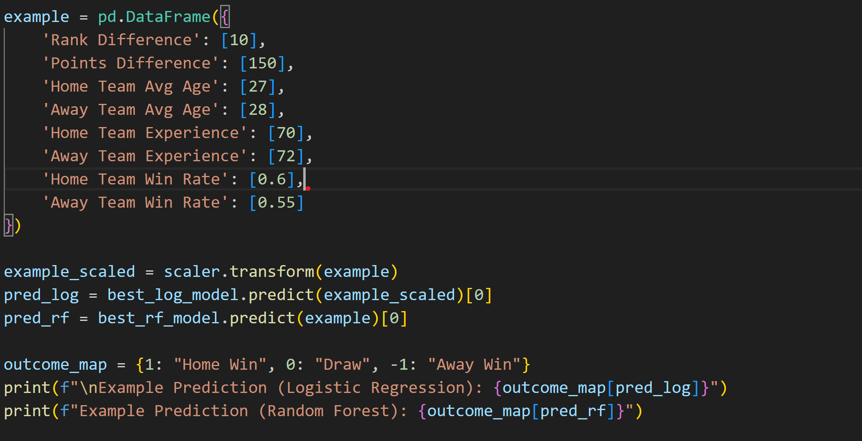
Explanation:
Both models predict that the home team is likely to win based on the input features, such as higher win rate, favorable rank and points difference, and average player experience. This demonstrates the models’ ability to evaluate team strengths and generate match outcome predictions.
- Code Sections
- Task 1 code:
- import pandas as pd
- from sklearn.model_selection import train_test_split
- from sklearn.linear_model import LogisticRegression
- from sklearn.metrics import accuracy_score
- from sklearn.preprocessing import StandardScaler
- import os

- # --- 0. LOAD CLEANED DATASET ---
- base_dir = r"C:\Users\test\OneDrive\Desktop\assignment2aiml"
- cleaned_file = 'cleaned_fifa_dataset.csv'
- path_cleaned = os.path.join(base_dir, cleaned_file)

- df_master = pd.read_csv(path_cleaned)
- print("Cleaned dataset loaded successfully.")

- # --- 1. SELECT FEATURES & TARGET ---
- features = ['Rank Difference', 'Points Difference',
- 'Home Team Avg Age', 'Away Team Avg Age',
- 'Home Team Experience', 'Away Team Experience',
- 'Home Team Win Rate', 'Away Team Win Rate']
- target = 'Home_Win'

- X = df_master[features]
- Y = df_master[target]

- # --- 2. SPLIT DATASET ---
- X_train, X_test, Y_train, Y_test = train_test_split(
- X, Y, test_size=0.2, random_state=42, stratify=Y
- )

- # --- 3. SCALE FEATURES ---
- scaler = StandardScaler()
- X_train_scaled = scaler.fit_transform(X_train)
- X_test_scaled = scaler.transform(X_test)

- # --- 4. TRAIN LOGISTIC REGRESSION ---
- model = LogisticRegression(solver='lbfgs', max_iter=5000)
- model.fit(X_train_scaled, Y_train)

- # --- 5. EVALUATE MODEL ---
- Y_pred = model.predict(X_test_scaled)
- accuracy = accuracy_score(Y_test, Y_pred)

- print("\n*** MODEL EVALUATION RESULTS ***")
- print(f"Features Used: {features}")
- print(f"Accuracy on Test Set: {accuracy * 100:.2f}%")

- # --- 6. EXAMPLE PREDICTION ---
- example_data = pd.DataFrame({
- 'Rank Difference': [10],
- 'Points Difference': [150],
- 'Home Team Avg Age': [27],
- 'Away Team Avg Age': [28],
- 'Home Team Experience': [70],
- 'Away Team Experience': [72],
- 'Home Team Win Rate': [0.6],
- 'Away Team Win Rate': [0.55]
- })

- example_scaled = scaler.transform(example_data)
- prediction = model.predict(example_scaled)[0]
- outcome_map = {1: "Home Win", 0: "Draw", -1: "Away Win"}
- print(f"\nExample Prediction (Stronger Home Team): {outcome_map[prediction]}")

- Output:
- 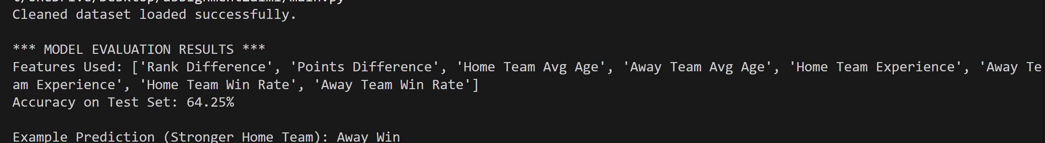

- Task 2 code:
- import pandas as pd
- from sklearn.model_selection import train_test_split, GridSearchCV, KFold, cross_val_score
- from sklearn.preprocessing import StandardScaler
- from sklearn.linear_model import LogisticRegression
- from sklearn.ensemble import RandomForestClassifier
- from sklearn.metrics import accuracy_score, classification_report
- import os

- # --- 0. LOAD CLEANED DATASET ---
- base_dir = r"C:\Users\test\OneDrive\Desktop\assignment2aiml"
- cleaned_file = 'cleaned_fifa_dataset.csv'
- path_cleaned = os.path.join(base_dir, cleaned_file)

- df = pd.read_csv(path_cleaned)
- print("Cleaned dataset loaded successfully.")

- # --- 1. SELECT FEATURES & TARGET ---
- # Using numeric features only; no encoding needed
- features = ['Rank Difference', 'Points Difference',
- 'Home Team Avg Age', 'Away Team Avg Age',
- 'Home Team Experience', 'Away Team Experience',
- 'Home Team Win Rate', 'Away Team Win Rate']
- target = 'Home_Win'

- X = df[features]
- y = df[target]

- # --- 2. SPLIT DATASET ---
- # Train-test split ensures model evaluation is fair
- X_train, X_test, y_train, y_test = train_test_split(
- X, y, test_size=0.2, random_state=42, stratify=y
- )

- # --- 3. SCALE FEATURES ---
- # Logistic Regression benefits from feature scaling
- scaler = StandardScaler()
- X_train_scaled = scaler.fit_transform(X_train)
- X_test_scaled = scaler.transform(X_test)

- # --- 4. LOGISTIC REGRESSION WITH HYPERPARAMETER TUNING ---
- # Removed 'multi_class' to avoid deprecation warning
- log_params = {
- 'C': [0.01, 0.1, 1, 10], # Regularization strength
- 'solver': ['lbfgs'] # lbfgs works for multiclass by default
- }
- log_grid = GridSearchCV(LogisticRegression(max_iter=5000), log_params, cv=5, scoring='accuracy')
- log_grid.fit(X_train_scaled, y_train)

- best_log_model = log_grid.best_estimator_
- y_pred_log = best_log_model.predict(X_test_scaled)

- # --- 5. RANDOM FOREST WITH HYPERPARAMETER TUNING ---
- # Random Forest does not require scaling
- rf_params = {
- 'n_estimators': [100, 200, 300],
- 'max_depth': [None, 5, 10],
- 'min_samples_split': [2, 5],
- 'min_samples_leaf': [1, 2]
- }
- rf_grid = GridSearchCV(RandomForestClassifier(random_state=42), rf_params, cv=5, scoring='accuracy')
- rf_grid.fit(X_train, y_train)

- best_rf_model = rf_grid.best_estimator_
- y_pred_rf = best_rf_model.predict(X_test)
- acc_rf = accuracy_score(y_test, y_pred_rf)
- print("\n*** Random Forest Results ***")
- print(f"Best Parameters: {rf_grid.best_params_}")
- print(f"Accuracy: {acc_rf*100:.2f}%")
- print(classification_report(y_test, y_pred_rf))

- # --- 6. K-FOLD CROSS-VALIDATION ---
- # Ensures model stability and fair evaluation over multiple splits
- kfold = KFold(n_splits=5, shuffle=True, random_state=42)
- cv_log = cross_val_score(best_log_model, scaler.transform(X), y, cv=kfold)
- cv_rf = cross_val_score(best_rf_model, X, y, cv=kfold) # RF does not require scaling

- print("\n*** Logistic Regression K-Fold Accuracy ***")
- print("Fold Accuracies:", cv_log)
- print("Average Accuracy:", cv_log.mean() * 100)

- print("\n*** Random Forest K-Fold Accuracy ***")
- print("Fold Accuracies:", cv_rf)
- print("Average Accuracy:", cv_rf.mean() * 100)

- # --- 7. EXAMPLE PREDICTION ---
- example = pd.DataFrame({
- 'Rank Difference': [10],
- 'Points Difference': [150],
- 'Home Team Avg Age': [27],
- 'Away Team Avg Age': [28],
- 'Home Team Experience': [70],
- 'Away Team Experience': [72],
- 'Home Team Win Rate': [0.6],
- 'Away Team Win Rate': [0.55]
- })

- example_scaled = scaler.transform(example)
- pred_log = best_log_model.predict(example_scaled)[0]
- pred_rf = best_rf_model.predict(example)[0]

- outcome_map = {1: "Home Win", 0: "Draw", -1: "Away Win"}
- print(f"\nExample Prediction (Logistic Regression): {outcome_map[pred_log]}")
- print(f"Example Prediction (Random Forest): {outcome_map[pred_rf]}")

- Output:
- 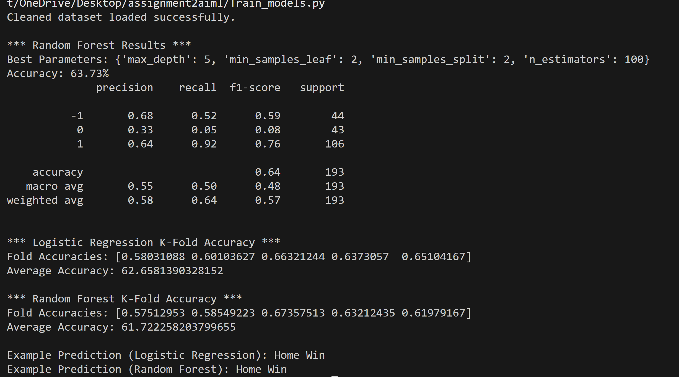
- Web Scraper Code:
- import requests
- from bs4 import BeautifulSoup
- import csv

- # Target page – FIFA World Cup Qatar 2022 teams list
- url = "https://www.fifa.com/en/tournaments/mens/worldcup/qatar2022/teams"
- page = requests.get(url)
- soup = BeautifulSoup(page.content, 'html.parser')

- # Find all team sections
- teams = soup.find_all('div', class_='TeamFigure_tf__jA5HW')

- # Create CSV file to store data
- with open('worldcup_teams.csv', 'w', newline='', encoding='utf-8') as file:
- writer = csv.writer(file)
- writer.writerow(['Team Name', 'Logo URL', 'Profile Link'])

- for team in teams:
- # Extract team name
- name_tag = team.find('a', class_='TeamFigure_tfMainLink__OPLFu')
- team_name = name_tag.text.strip() if name_tag else 'N/A'

- # Extract logo URL
- logo_tag = team.find('img')
- logo_url = logo_tag['src'] if logo_tag else 'N/A'

- # Extract profile link
- profile_link = name_tag['href'] if name_tag else 'N/A'

- # Write to CSV
- writer.writerow([team_name, logo_url, profile_link])

- print("Data scraped successfully and saved in 'worldcup_teams.csv'")

Output:
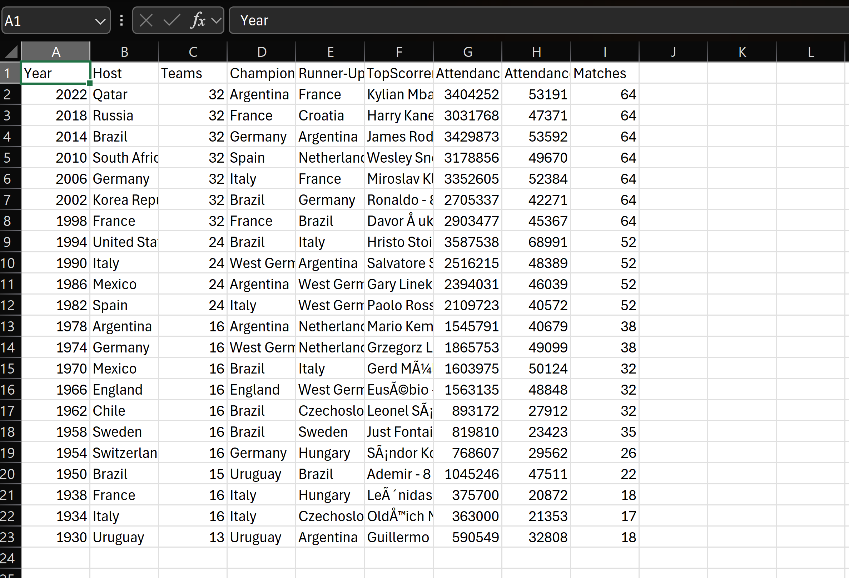
These are the details scraped using above code and code have only world cup 2022 data, just to clarify scraping workflow, I will modify further for future use

